$50 for a photo!

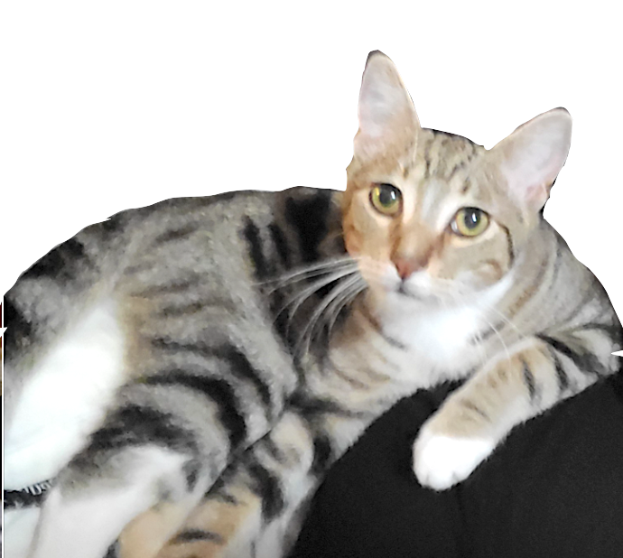

…IF confirmed as our missing cat. If seen

please DO NOT CHASE!

just call or text a photo to
404.996.0116
$50 for a photo!

Replace this box with a closely cropped
side-view photo of your cat with the background silhouetted out.

It’s important that your cat’s full body, shape and markings are easily recognized at a glance and in a position they would be seen.

Once you have your flyers created, print full size for putting on orange posters and choose the 4-to-a-page option in the print window to get the mini version for handing out in person.

…IF confirmed as our missing cat. If seen

please DO NOT CHASE!

just call or text a photo to
xxx.xxx.xxxx

