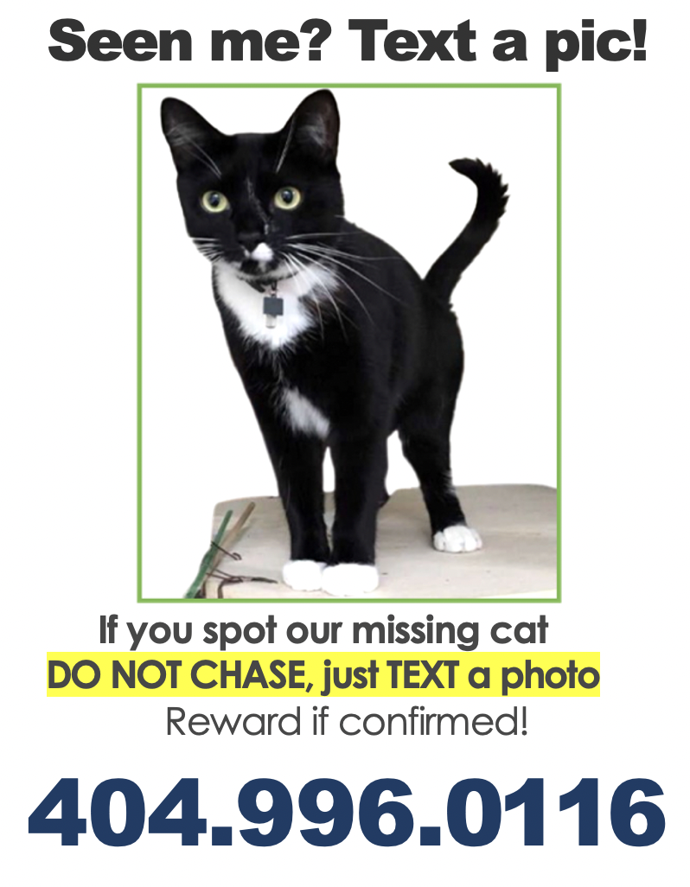
Seen me? Text a pic!
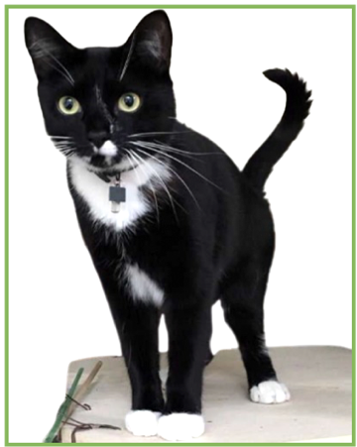
If you spot our missing cat
DO NOT CHASE, just TEXT a photo
Reward if confirmed!
404.996.0116
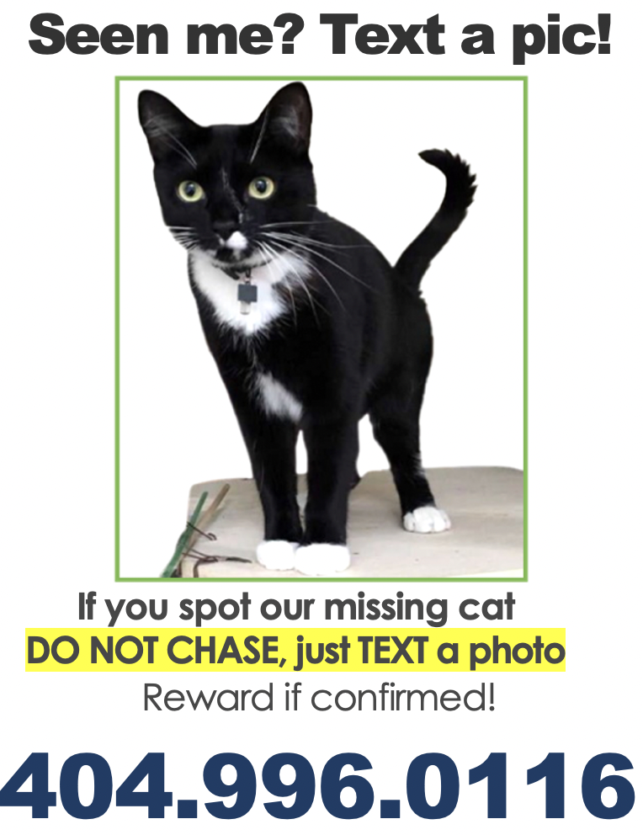

- Start with page 2 to add your cat’s info. Once you have everything in place take a screenshot of the entire flyer, then paste it into four quadrants as shown above OR you can set your printer on “4 to a page” in the Print dialog box.

- Once you have your 4 -up mini flyers to hand out in person, add another full-size version screenshot to a new page.

- Too add orange border, go to FORMAT PICTURE click on PAINT BUCKET icon and choose LINE then SOLID and a width for the border. If you plan to mount them on orange posterboard or foam sheets, you can skip this step.

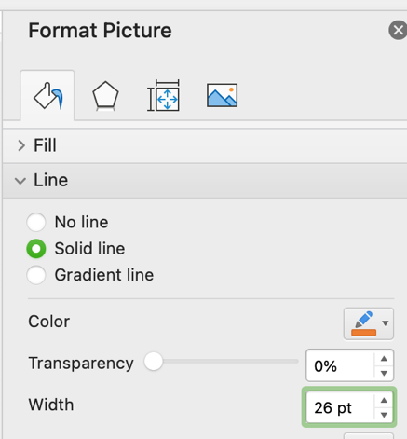

- Once you have everything the way you want it, be sure to erase all this text before printing!

- Remember to use the best photo of your cat as large as possible, ideally a side view sitting or standing as people will see them out in the world!

Kim Freeman
The Cat Detective

